Creating a new workspace
- mkdir -p ~/ros2_ws/src
- cd ~/ros2_ws
- colcon build
- source install/setup.bash
Creating a new package
- cd ~/ros2_ws/src
- ros2 pkg create --build-type ament_python my_package
#Replace my_package with our package name
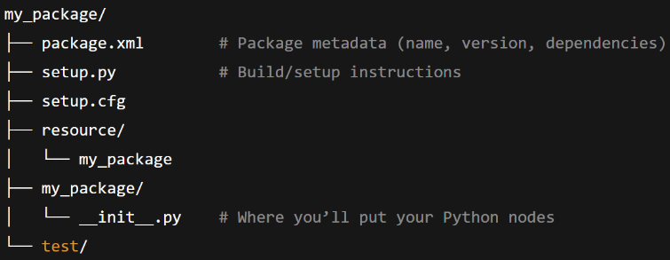
- In package.xml, Add dependencies
<depend>rclpy</depend>
<depend>geometry_msgs</depend>
<depend>turtlesim</depend>
- cd ~/ros2_ws
- colcon build
- source install/setup.bash

Creating a publisher
- cd ros2_ws/src/turtle_controller/turtle_controller
- nano turtle_publisher.py
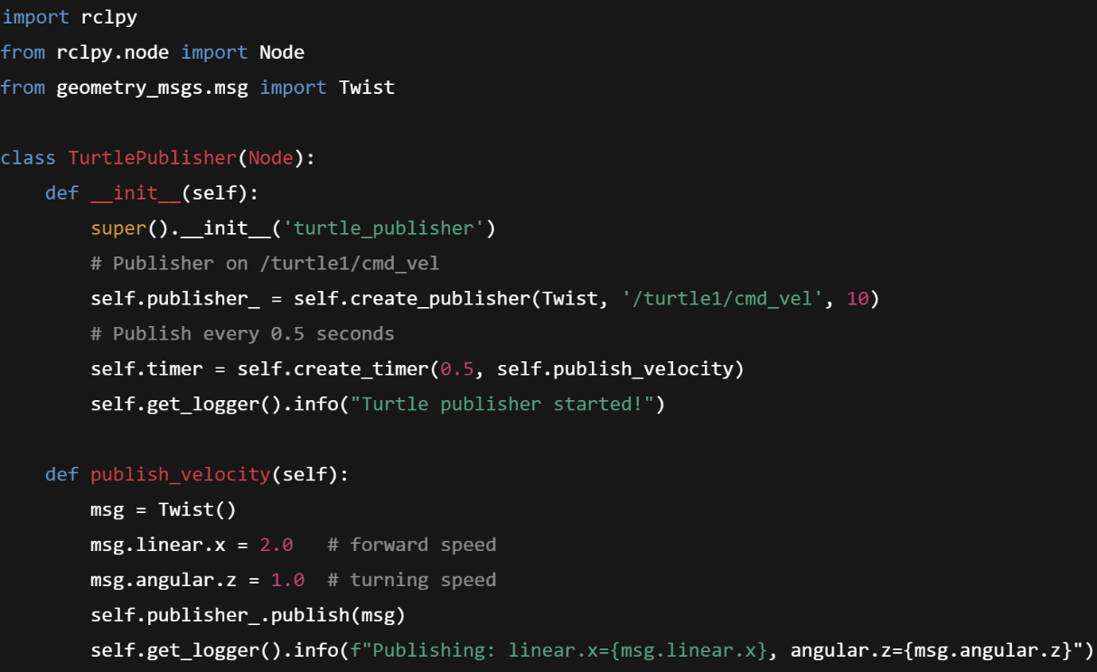
- Write

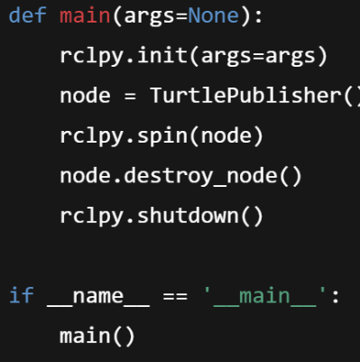

- cd ~/ros2_ws/src/turtle_controller
- nano setup.py
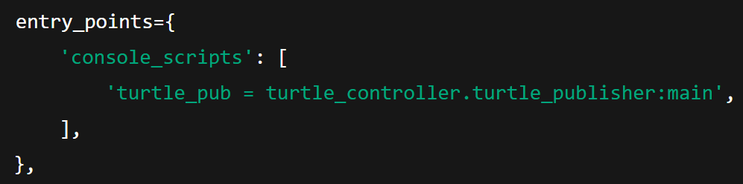
- Add

- cd ~/ros2_ws
- colcon build

Creating a subscriber
- cd ros2_ws/src/turtle_controller/turtle_controller
- nano turtle_subscriber.py
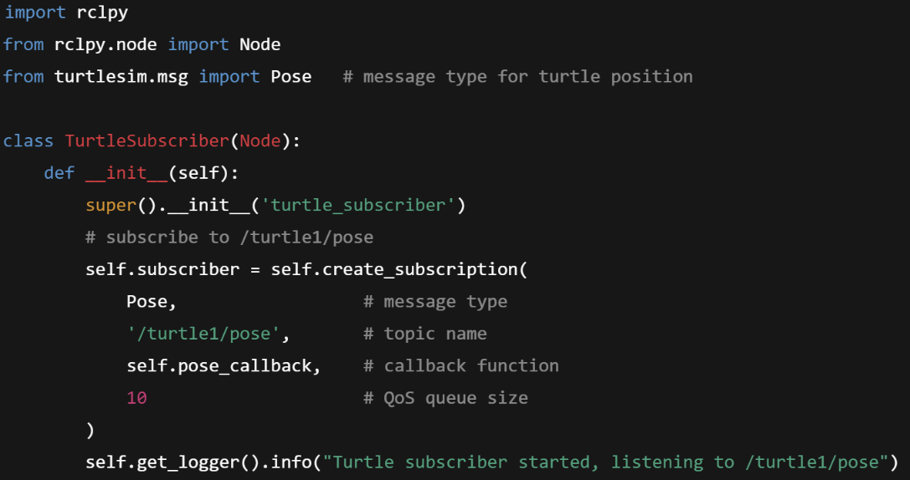
- Write

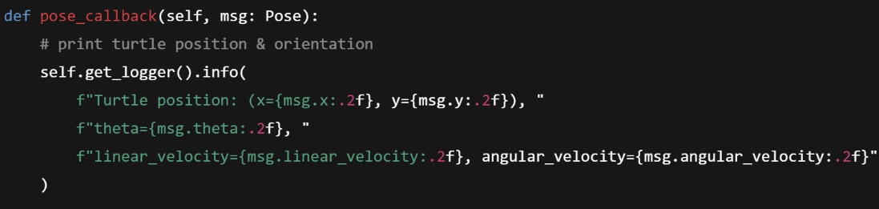

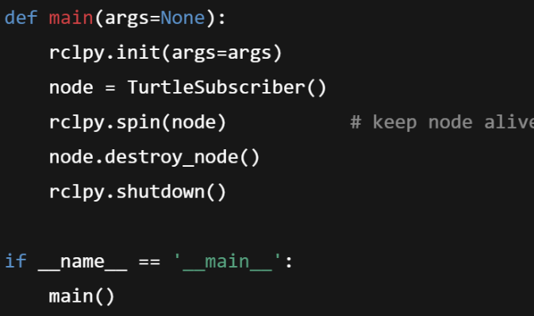

- cd ~/ros2_ws/src/turtle_controller
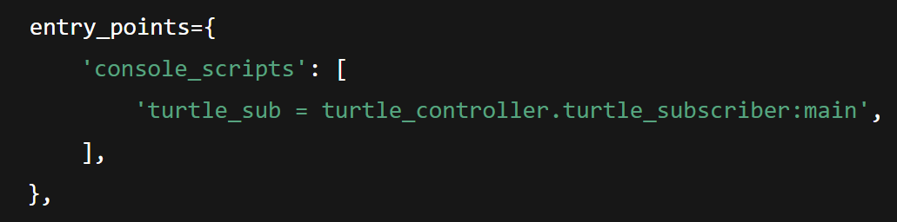
- nano setup.py
- Add

- cd ~/ros2_ws
- colcon build
Running all nodes
- Opening 3 terminals
- For each terminal, run
cd ros2_ws
source install/setup.bash
- In first terminal, ros2 run turtlesim turtlesim_node
- In second terminal, ros2 run turtle_controller turtle_pub
- In third terminal, ros2 run turtle_controller turtle_sub

Constructing Twist() msg
msg = Twist()
msg.linear.x =2.0
msg.angular.z =1.0
print(msg)
linear:
x: 0.0
y: 0.0
z: 0.0
angular:
x: 0.0
y: 0.0
z: 0.0

x: 5.5
y: 5.5
theta: 1.57
linear_velocity: 2.0
angular_velocity: 1.0

Constructing Pose() msg
pose = Pose()
pose.x = 5.5
pose.y = 5.5
pose.theta = 1.57
pose.linear_velocity = 2.0
pose.angular_velocity = 1.0

